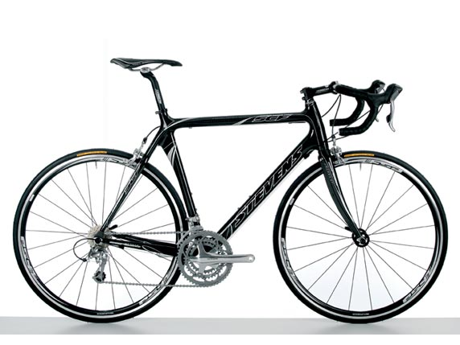
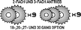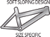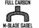

Introduction
The new carbon machine radiates an unequalled fascination: Nobly resplendent fiber directions, flowing organic tubing transitions and then still another synthesis from achievement and weight that is unsurpassed. With a control actuator rigidity of 94.6 Nm/° and a rigidity of 106.3 Nm/° the SCF 2 exceeds most aluminum frameworks in the market and is nevertheless super and easy. In the complete wheel with the m Blade full carbon fork and a Shimano Ultegra equipment composed, he remains also concerning the price on the soil and is considered as Top recommendation to running drivers and aesthetes.

Features
Frame material Carbon Monocoque HMF Composite
Fork Full carbon m-Blade, 1 1/8"carbon shank
Ball-head FSA Integrated 8C, carbon Cap 1 1/8"
Crank set Shimano Ultegra 52-39-30
Interior camps Shimano Ultegra integrated
Derailleur Back Shimano Ultegra 6600
Derailleur Front Ultegra 6600 and 6603
Chain Shimano Ultegra 6600
Cartridge Ultegra of 6600 12-25
(12,13,14,15,16,17,19,21,23,25)
Wheel set FSA RD 400, Alloy cartridge body
Hub Rear Shimano Ultegra 6600
Hub Front Ultegra 6600
Rims Mavic CXP22N, CNC side 32 L
Spokes DT Swiss Competition 2.0-1.8mm
Tires Continental Ultra 3000, 700*23C
Steering wheel Oxygen Scorpo 31.8mm
Porch Oxygen Scorpo OS
Saddle Oxygen Cyrius
Saddle bar Oxygen Scorpo
Control lever Shimano Ultegra STI
Brakes Shimano Ultegra
Pedals Shimano 6610

Weight 7,6 kg
Size 56 cm
Color Carbon Nature
Detailed specifications

Hollowtech II Crankset FC-6603
Hollowtech II Crankset for use triple gearing configurations

Specifications
HYPERDRIVE Yes
DUAL SIS Yes
Chain compatibility Super Narrow HG for 10-speed
Hollow Crank Arm HOLLOWTECH II
Reinforced Spider Yes
Number of Teeth 52-39-30T
Bolt Circle Diameter 130/74mm
Crank Arm Length 165/170/172.5/175mm
Crank Arm forged aluminum/anodized
Chain rings aluminum/anodized
Average Weight 922g 170mm, integrated BB
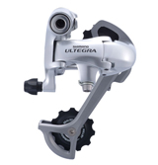 | Rear Derailleur RD-6600-GS  Rear Derailleur for use with triple gearing configurations  Specifications  Speeds 10-speed  Max. Sprocket 27T  Min. Sprocket 11T  Max Front Difference 23T  Total Capacity 38T  Guide Pulley sealed ceramic bushing  Tension Pulley sealed bearing  11T Pulley Yes  Bracket Body aluminum/clear coated  Bracket Body Pivot Seal double O-rings  Plate Body aluminum/clear coated  Plate Body Pivot Seal single O-ring  Outer Link aluminum/clear coated  Inner Link aluminum/barrel  Sealed Link Pins outer/inner link  Link Pin Bushings fluorine coated (4)  Outer Plate aluminum/anodized  Inner Plate aluminum/barrel  Average Weight 219g
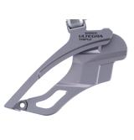 | Front Derailleur (braze-on) FD-6603-F  Front Derailleur for use with triple gearing configurations  Specifications  Rear speeds 10-speed  DUAL SIS Yes  Top Gear Teeth 52T  Capacity 22T(Triple)  Link Bushing lower/A-pin  O-ring Seals No  Spring Cover Yes  Chain Stay Angle 63-66 deg.  Mounting brazed-on  Compatible Adopter SM-AD11: 31.8mm/SM-AD15: 34.9mm  Applicable Chain line 45mm  Band/Brazed-on Clamp aluminum/clear coated  Outer Link aluminum/clear coated  Inner Link aluminum/clear coated  Chain Guide steel/pearl bright finish  Average Weight 113g
Detailed specifications (continued)

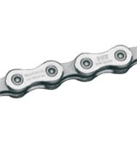 | 10-Speed Chain CN-6600  Super Narrow Chain for 10-speed  Specifications  Type Super Narrow HG for 10-speed  Pin Link Plate zinc-alloy plated  Roller Link Plate gray  Chromizing Treatment Yes  Link Pin  Average Weight 280g (116links)
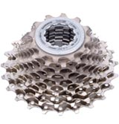 | Cassette Sprockets CS-6600  12,13,14,15,16,17,19,21,23,25 teeth  Specifications  Speed 10-speed  Finish nickel plated  Average Weight 235g (12-13T)
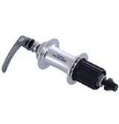 | Rear Free hub FH-6600  Super polished ball races for high precision, durability and smooth rotation  Specifications  No. of Sprockets 10,9,8-speed  Over Locknut 130mm  Axle Length 141mm  Spoke Holes 36/32/28/24, 24 (aero)  Spoke holeCircle 45mm  Sealing labyrinth and contact seals  Free hub Body steel  Hub Shell forged aluminum/anodized  Center to Flange Right : 20.8mm Left:38.4mm  Average Weight 347g  QR Weight 64g
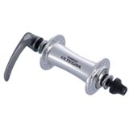 | Front Hub HB-6600  Radial lacing compatible, internal grease sleeve  Specifications  Over Locknut 100mm  Axle Length 108mm(M9)  Spoke Holes 36/32/28/24,18(aero type)  Spoke hole Circle 38mm  Sealing labyrinth and contact seals  Hub Shell cold forged aluminum/anodized  Center to Flange Right & Left: 35.8m  Average Weight 140g  QR Weight 60g
Detailed specifications (continued)

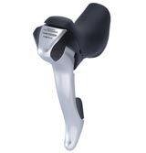 | S.T.I. Levers ST-6603  S.T.I. Integrated Shift / Brake lever for 10-speed triple gearing configurations  Specifications  Rear 10-speed  Front triple  FLIGHT DECK SM-SC70  Gear Sensor Yes  Max. Single-Stroke Shifts 3 (rear)  Handle Bar Diameter 23.8-24.2mm  Bracket engineering plastic  Levers aluminum/clear coated  Super SLR Yes  Shift Cable Casing SIS-SP41  Shift Cable stainless steel  Average Weight 243g (for front)
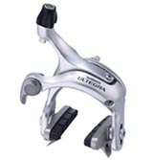 | Dual-Pivot Caliper Brake BR-6600  Compact & lightweight design, adjustable brake shoes  Specifications  Type Super SLR dual pivot  Reach 49mm  Pads R55C2  Cartridge shoe holder Yes  Caliper cold forged aluminum/anodized  C-Arm Pivot coated pivot washer  Y-Arm Pivot thrust bearing  Average Weight 330g(F&R)
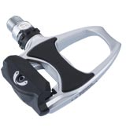 | Ultegra SPD-SL PD-6610  SPD-SL Road Racing Pedal  Specifications  Type SPD-SL  Road Clearance 34deg.  Cleat Retention Adjuster Yes  Cleat Retention Indicator Yes  Spindle Thread BC 9/16"x 20T.P.I.  Spindle chrome-moly steel  Body aluminum/painted  Average Weight 308g
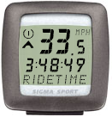 | Sigma Sport BC 1200 + RDS  Wireless Cycle Computer  Specifications  Type BC 1200  Functions Current speed; Clock; Stopwatch; Trip Distance; 2 Wheels programmable; (Trip) riding time; Maximum speed; Average speed  Radio data system Interference free transmission (guaranteed by calculation mechanism for max. 2% of the data)  Average Weight … g
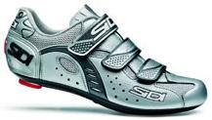 | Sidi Zeta High-Tech Carbon Fibre  Upper in synthetic leather with a high-tech carbon fibre sole  Specifications  Color Silver  Size EUR 10; USA 10  Average Weight … g

